Damon Quire

Surgery On Sunday

Quality Control

Assignment 3

CIS 320

Surgery On Sunday

Version 1.0

Revision History

|  |  |  |  |
| --- | --- | --- | --- |
| **Date** | **Version** | **Description** | **Author** |
| 10/23/2017 | 1.0 | Generate Interpreter Report | Damon Quire |
|  |  |  |  |
|  |  |  |  |
|  |  |  |  |

Table of Contents

1. Generate Interpreter Report 4

1.1 Brief Description 4

2. Flow of Events 4

2.1 Basic Flow 4

2.2 Alternative Flows 4

3. Special Requirements 4

3.1 User Must be Logged In, Information Must be Available 4

4. Pre-conditions 4

4.1 User Must be Logged In 4

5. Post-conditions 4

5.1 Information is Displayed 4

6. Extension Points 4

Use Case Specification:

# Generate Interpreter Report

## Brief Description

The objective of this use case is to show how a program coordinator would go about requesting a report about the available interpreters. This is necessary so that SOS can appropriately assign the correct interpreter based on the patient’s surgery and primary language. This way, instead of manually searching through all of the files available on interpreters, they instead can obtain a report showing all available staff or volunteers that are qualified.

# Flow of Events

## Basic Flow

* A user wants to access interpreter information for a particular surgery’s needs
* Program Coordinator logs in with their authorization
* Program Coordinator navigates to reports tab
* Program Coordinator navigates to interpreters within reports
* Program Coordinator saves or prints reports with necessary data
* Program Coordinator logs out of system

## Alternative Flows

There are no alternative flows

# Special Requirements

## -User must be logged into their account and have the proper authorization to view and access the data.

-Data must already exist in database to be accessed.

# Pre-conditions

## User must be logged into the system with appropriate credentials.

# Post-conditions

## Information on interpreters is displayed and may be saved or printed.

# Extension Points

There are no extension points.

**C**

**Methods**

* Create Interpreter Record
* Update Interpreter Record
* Delete Interpreter Record
* Email Interpreter
* Generate Report of Interpreters

**Attributes:**

* First Name
* Last Name
* City
* State
* Zip
* Address
* Licenses
* Phone number
* Email address
* Hospital affiliation
* Primary language
* Secondary language if exists

**Interpreter**

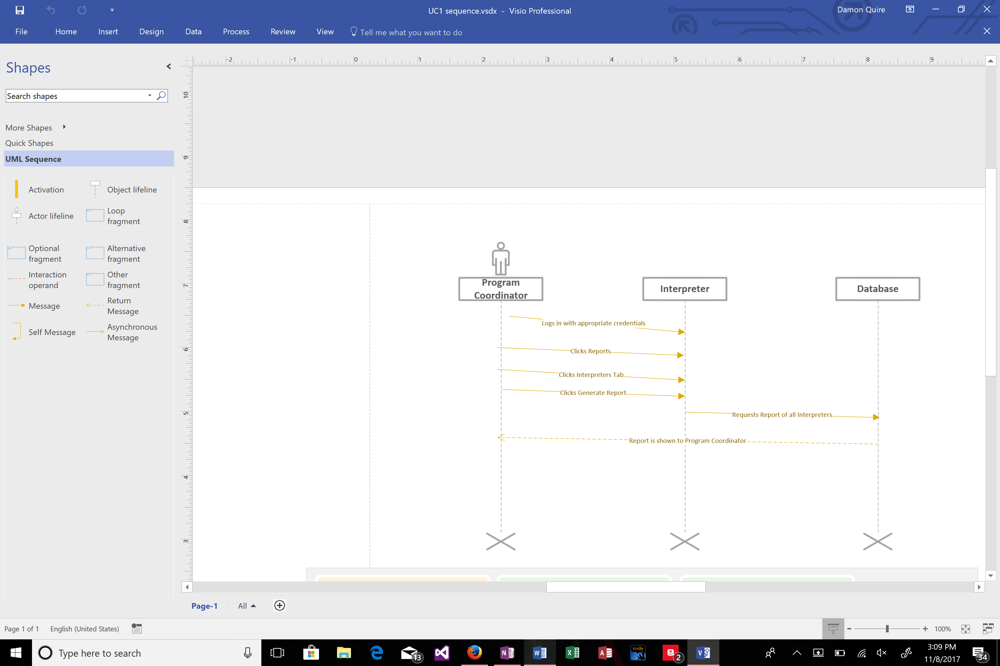

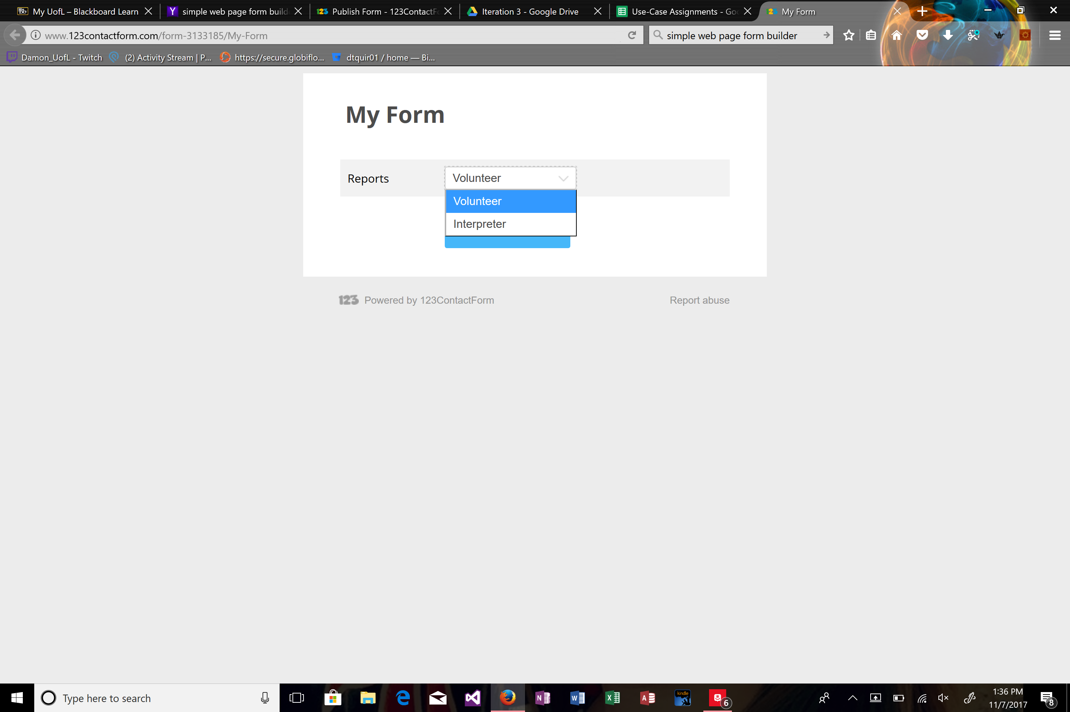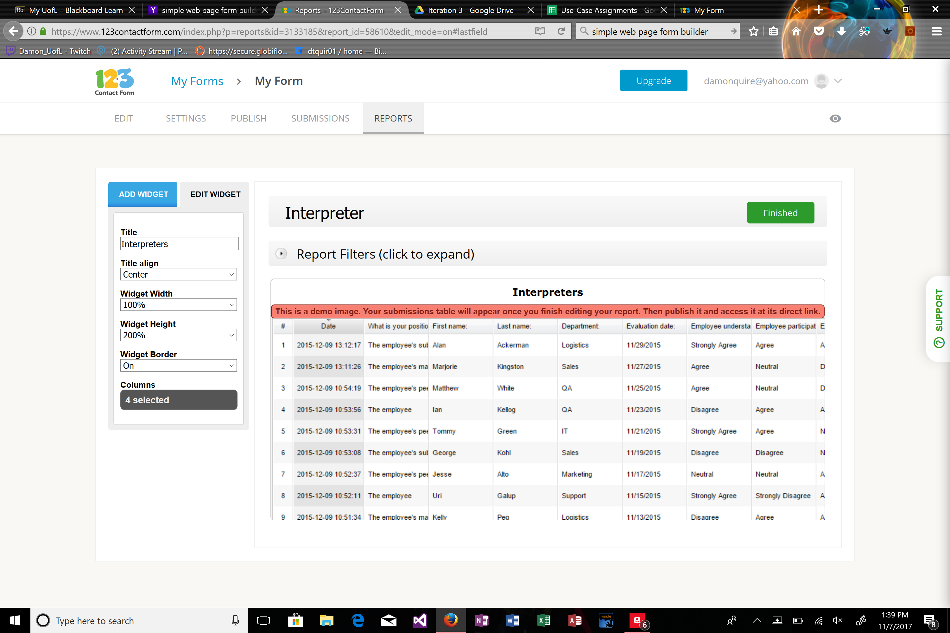

Surgery On Sunday

Version 1.0

Revision History

|  |  |  |  |
| --- | --- | --- | --- |
| **Date** | **Version** | **Description** | **Author** |
| 10/23/2017 | 1.0 | Send Email To Interpreters | Damon Quire |
|  |  |  |  |
|  |  |  |  |
|  |  |  |  |

Table of Contents

1. Send Email To Interpreters 4

1.1 Brief Description 4

2. Flow of Events 4

2.1 Basic Flow 4

2.2 Alternative Flows 4

3. Special Requirements 4

3.1 User Must be Logged In, Information Must be Available, Interpreter supplied email 4

4. Pre-conditions 4

4.1 User Must be Logged In 4

5. Post-conditions 4

5.1 Email is Sent 4

6. Extension Points 4

Use Case Specification:

# Send Email to Interpreters

## Brief Description

The objective of this use case is to show how a program coordinator would go about emailing available interpreters. This is necessary so that SOS can appropriately assign the correct interpreter based on the patient’s surgery and primary language and make sure they’re available and aware of the event. This way, instead of manually searching through all of the files available on interpreters, they instead access all of the email addresses of qualified interpreters and ask them about their availability, or should they have already signed up, remind them of the upcoming event and supply them with further details.

# Flow of Events

## Basic Flow

* A user wants to access appropriate interpreter email addresses
* Program Coordinator logs in with their authorization
* Program Coordinator navigates email tab
* Program Coordinator navigates to interpreters within email categories
* Program Coordinator finds appropriate interpreters
* Program Coordinator accesses their email addresses
* Program Coordinator inputs them into plug in
* Program Coordinator sends email to all possible/already signed up interpreters
* Program Coordinator logs out of system

## Alternative Flows

There are no alternative flows

# Special Requirements

## -User must be logged into their account and have the proper authorization to view and access the data

-Data must already exist in database to be accessed

-Interpreter must have supplied email address prior to accessing

# Pre-conditions

## User must be logged into the system with appropriate credentials.

# Post-conditions

## Email is sent to appropriate email addresses

# Extension Points

There are no extension points.



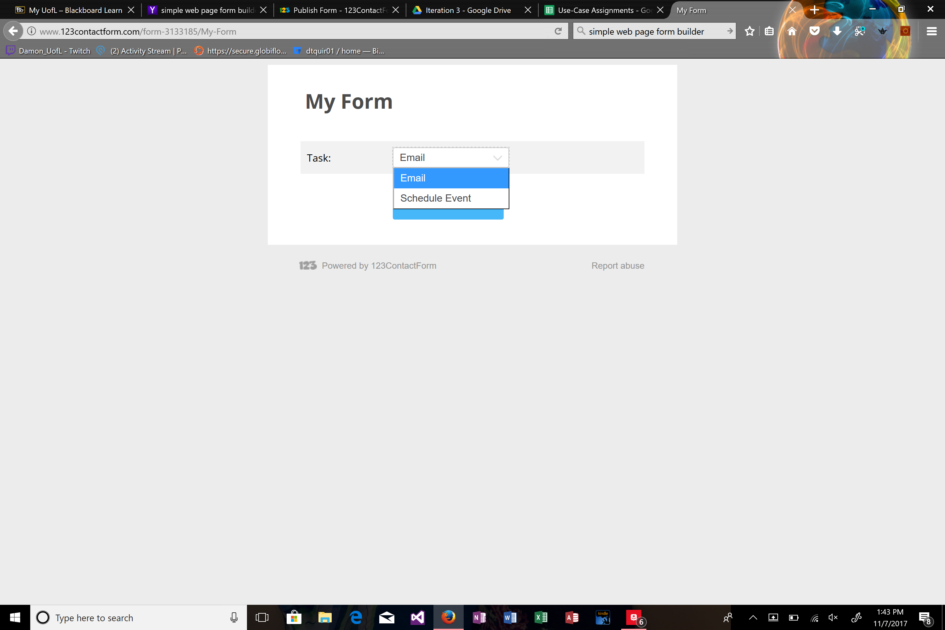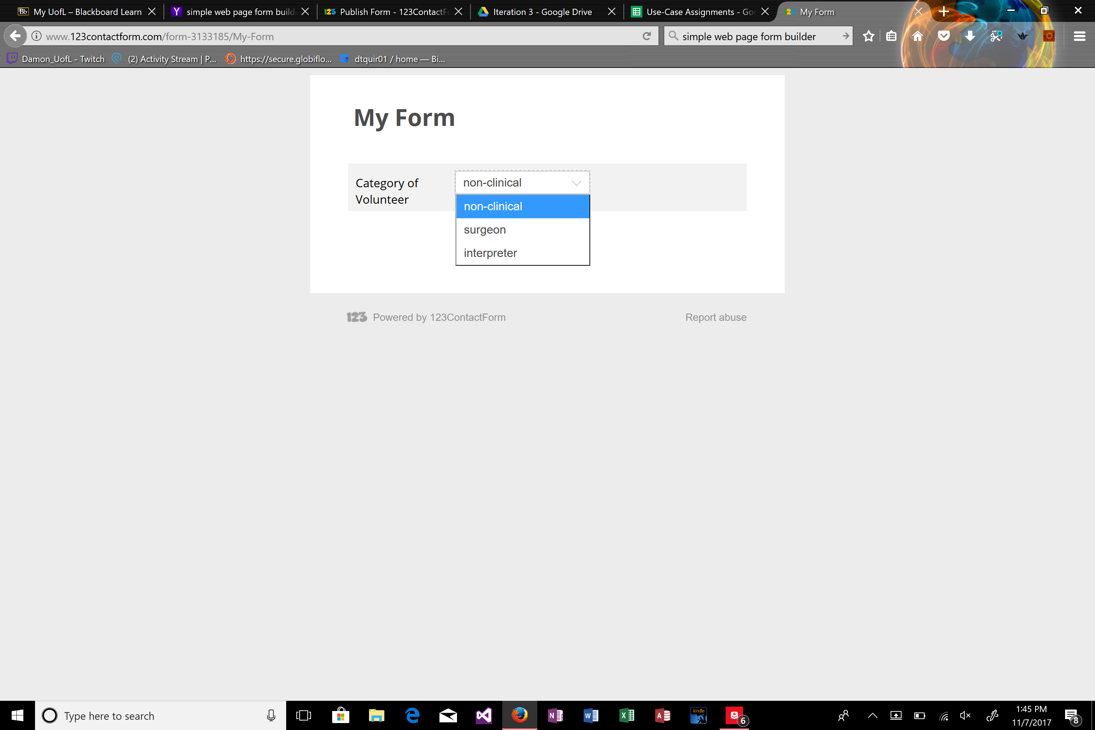

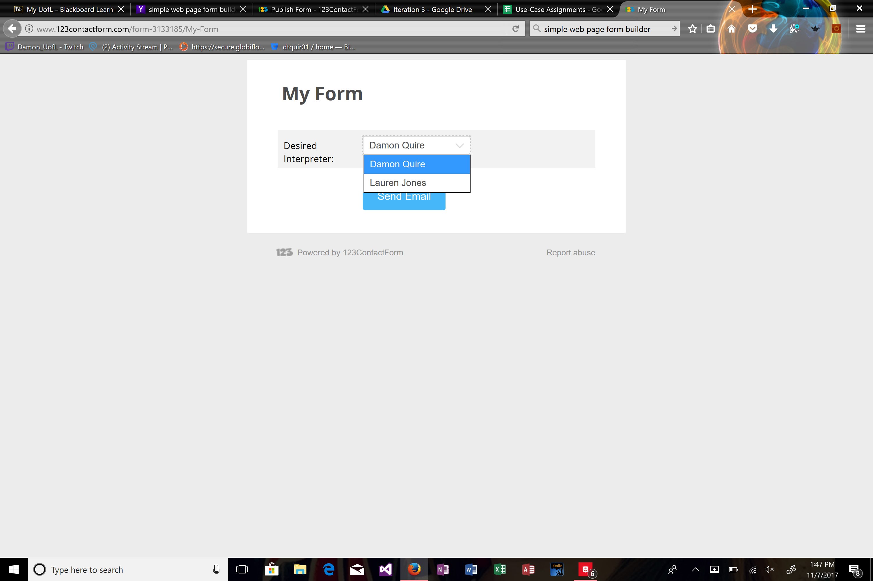

Surgery On Sunday

)

Version 1.0

Revision History

|  |  |  |  |
| --- | --- | --- | --- |
| **Date** | **Version** | **Description** | **Author** |
| 10/23/2017 | 1.0 | Schedule Event With Appropriate Interpreter(s) | Damon Quire |
|  |  |  |  |
|  |  |  |  |
|  |  |  |  |

Table of Contents

1. Schedule Event With Appropriate Interpreter(s) 4

1.1 Brief Description 4

2. Flow of Events 4

2.1 Basic Flow 4

2.2 Alternative Flows 4

3. Special Requirements 4

3.1 User Must be Logged In, Information Must be Available, Interpreter Must Be Qualified 4

4. Pre-conditions 4

4.1 User Must be Logged In 4

5. Post-conditions 4

5.1 Event is Scheduled 4

6. Extension Points 4

Use Case Specification:

# Schedule Event With Appropriate Interpreter(s)

## Brief Description

The objective of this use case is to show how a program coordinator would go about scheduling an event with the available interpreters. This is necessary so that SOS can appropriately assign the correct interpreter based on the patient’s surgery and primary language so that any patient needs will be properly addressed. This way, instead of manually searching through all of the files available on interpreters, they instead access all of the qualified interpreters and can schedule the event with those available and qualified.

# Flow of Events

## Basic Flow

* A user wants to schedule an event
* Program Coordinator logs in with their authorization
* Program Coordinator navigates to schedule event tab
* Program Coordinator fills out date of event field
* Program Coordinator fills out location of event field
* Program Coordinator fills out patient field
* Program Coordinator fills out selected nurses field
* Program Coordinator fills out selected volunteers field
* Program Coordinator fills out surgeon field
* Program Coordinator fills out selected interpreter field
* Program Coordinator clicks submit
* Program Coordinator logs out

## Alternative Flows

There are no alternative flows

# Special Requirements

## -User must be logged into their account and have the proper authorization to view and access the data

-Data must already exist in database to be accessed

-Interpreter must be qualified in order to select

# Pre-conditions

## User must be logged into the system with appropriate credentials.

# Post-conditions

## Event is Scheduled

# Extension Points

There are no extension points.



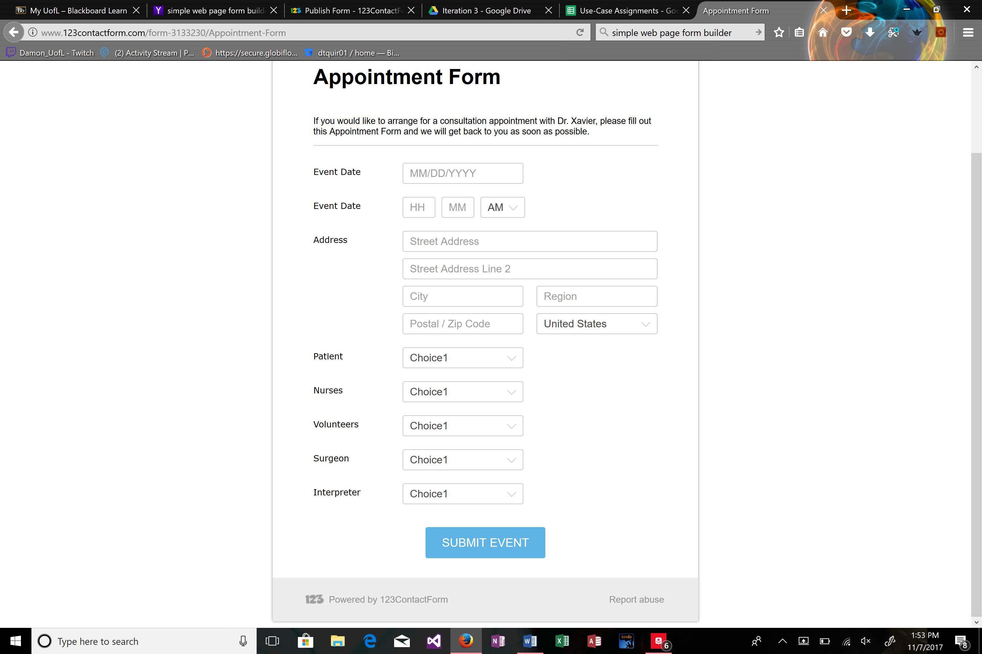

Surgery On Sunday

)

Version 1.0

Revision History

|  |  |  |  |
| --- | --- | --- | --- |
| **Date** | **Version** | **Description** | **Author** |
| 10/23/2017 | 1.0 | Send Thank You Emails to Appropriate Interpreter(s) | Damon Quire |
|  |  |  |  |
|  |  |  |  |
|  |  |  |  |

Table of Contents

1. Send Thank You Emails to Appropriate Interpreter(s) 4

1.1 Brief Description 4

2. Flow of Events 4

2.1 Basic Flow 4

2.2 Alternative Flows 4

3. Special Requirements 4

3.1 User Must be Logged In, Information Must be Available, Must Access Mail Munch 4

4. Pre-conditions 4

4.1 User Must be Logged In 4

5. Post-conditions 4

5.1 Email is Sent 4

6. Extension Points 4

Use Case Specification: )

# Send Thank You Emails to Appropriate Interpreter(s)

## Brief Description

The objective of this use case is to show how a program coordinator would go about sending a thank you email the appropriate interpreters. This is necessary so that SOS can appropriately thank the interpreter(s) that have generously donated their time in order to help SOS and the patient. This way, instead of manually searching through all of the files available on interpreters, they instead access all of interpreters that worked the event and can easily send them emails.

# Flow of Events

## Basic Flow

* A user wants to show thanks for interpreter volunteer
* Program Coordinator logs in with their authorization
* Program Coordinator navigates to past events tab
* Program Coordinator finds appropriate event
* Program Coordinator navigates to interpreter field
* Program Coordinator selects the appropriate interpreter(s) email address
* Program Coordinator navigates to mail plugin
* Program Coordinator imports these email addresses
* Program Coordinator sends email
* Program Coordinator logs out of plugin
* Program Coordinator logs out of SOS website

## Alternative Flows

There are no alternative flows

# Special Requirements

## -User must be logged into their account and have the proper authorization to view and access the data

-Data must already exist in database to be accessed

-User must have access to Mail Munch

# Pre-conditions

## User must be logged into the system with appropriate credentials.

# Post-conditions

## Email is sent.

# Extension Points

There are no extension points.



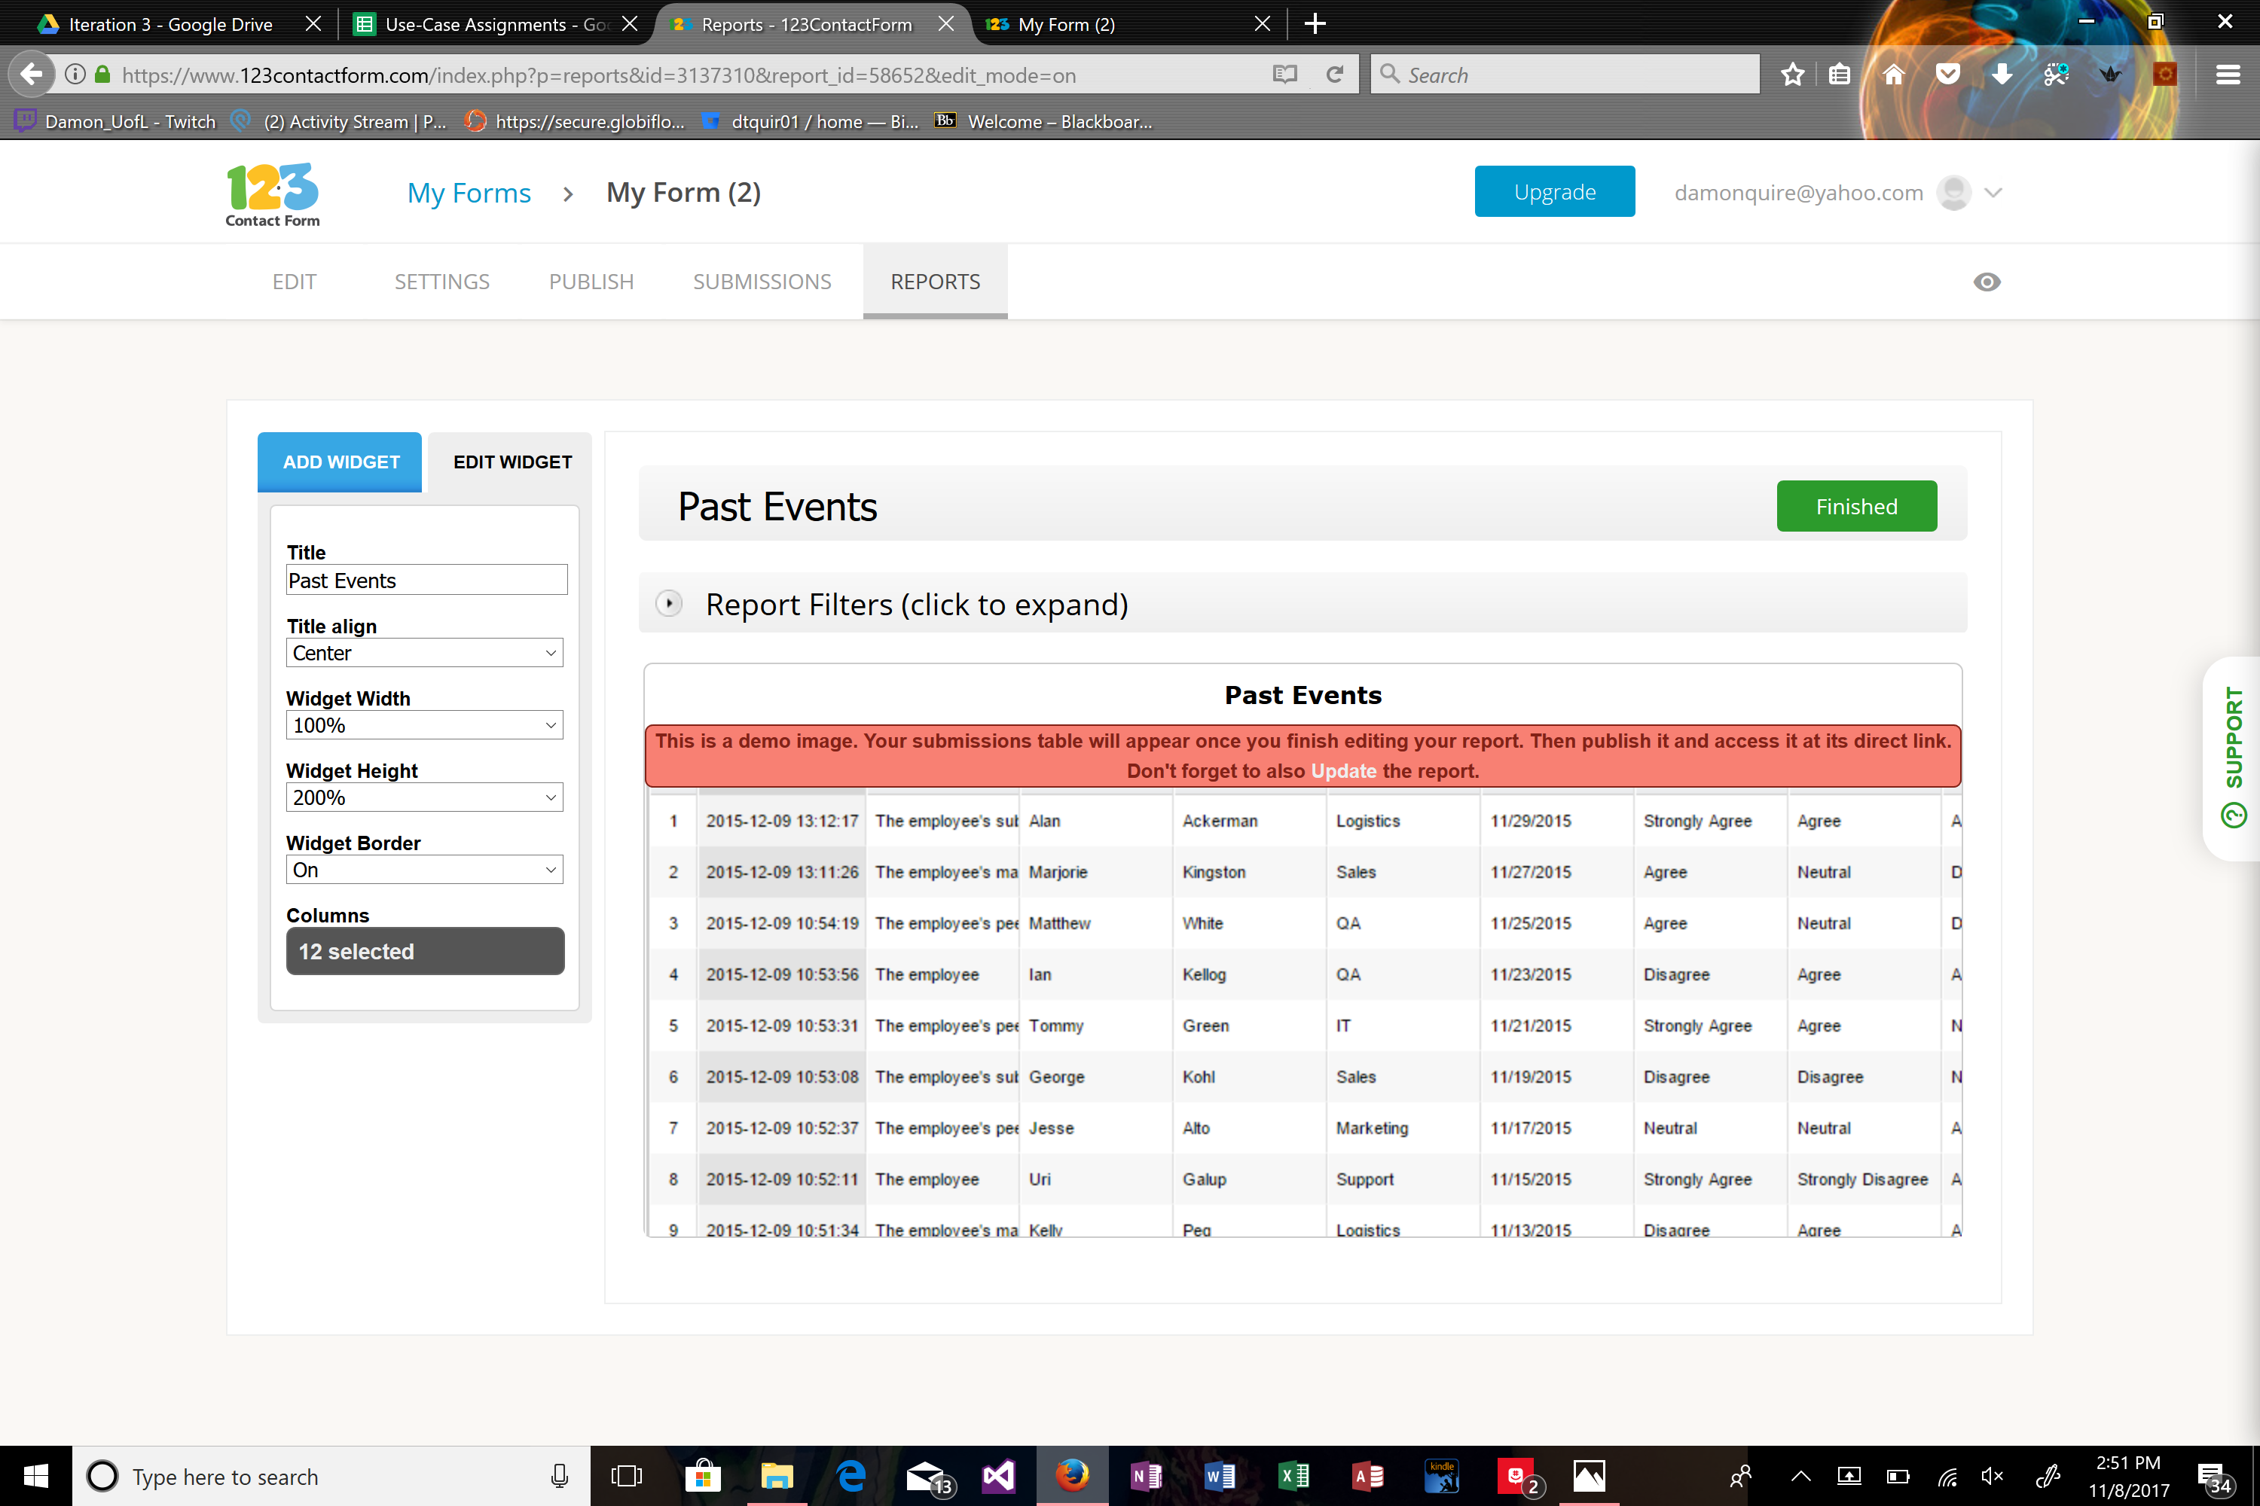

Surgery On Sunday

Version 1.0

Revision History

|  |  |  |  |
| --- | --- | --- | --- |
| **Date** | **Version** | **Description** | **Author** |
| 10/23/2017 | 1.0 | Add New Non-Clinical Volunteer | Damon Quire |
|  |  |  |  |
|  |  |  |  |
|  |  |  |  |

Table of Contents

1. Add New Non-Clinical Volunteer 4

1.1 Brief Description 4

2. Flow of Events 4

2.1 Basic Flow 4

2.2 Alternative Flows 4

3. Special Requirements 4

3.1 User Must Fill Out All Required Fields 4

4. Pre-conditions 4

4.1 None 4

5. Post-conditions 4

5.1 Volunteer is Added to Database 4

6. Extension Points 4

Use Case Specification: Add New Non-Clinical Volunteer

# Add New Non-Clinical Volunteer

## Brief Description

The objective of this use case is to show how a Volunteer would go about signing up as a non-clinical volunteer, and how the system handles this request. This is necessary so that SOS can appropriately store and receive volunteer information. This way, instead of manually searching through all of the files available on volunteers, the information will be properly stored and will be easier to access.

# Flow of Events

## Basic Flow

* A user wants to volunteer
* Volunteer navigates to SOS website
* Volunteer navigates to volunteer application
* Volunteer fills out First Name field
* Volunteer fills out Last Name field
* Volunteer fills out City field
* Volunteer fills out State field
* Volunteer fills out Zip field
* Volunteer fills out Address field
* Volunteer fills out Licenses field
* Volunteer fills out Phone number field
* Volunteer fills out Email address field
* Volunteer fills out Hospital affiliation field
* Volunteer fills out Primary language field
* Volunteer fills out Secondary language if exists field
* Volunteer clicks submit
* System stores information in appropriate table
* Information is now accessible by program coordinator
* Volunteer closes tab

## Alternative Flows

There are no alternative flows

# Special Requirements

## -User must fill out all required elements

# Pre-conditions

## None

# Post-conditions

## Information is stored properly.

# Extension Points

There are no extension points.

**C**

**Methods**

* Create Non-Clinical Volunteer Record
* Update Non-Clinical Volunteer Record
* Delete Non-Clinical Volunteer Record
* Email Non-Clinical Volunteer
* Generate Report of Non-Clinical Volunteer

**Attributes:**

* First Name
* Last Name
* City
* State
* Zip
* Address
* Phone number
* Email address
* Primary language
* Secondary languages if exists

**Non-Clinical Volunteer**



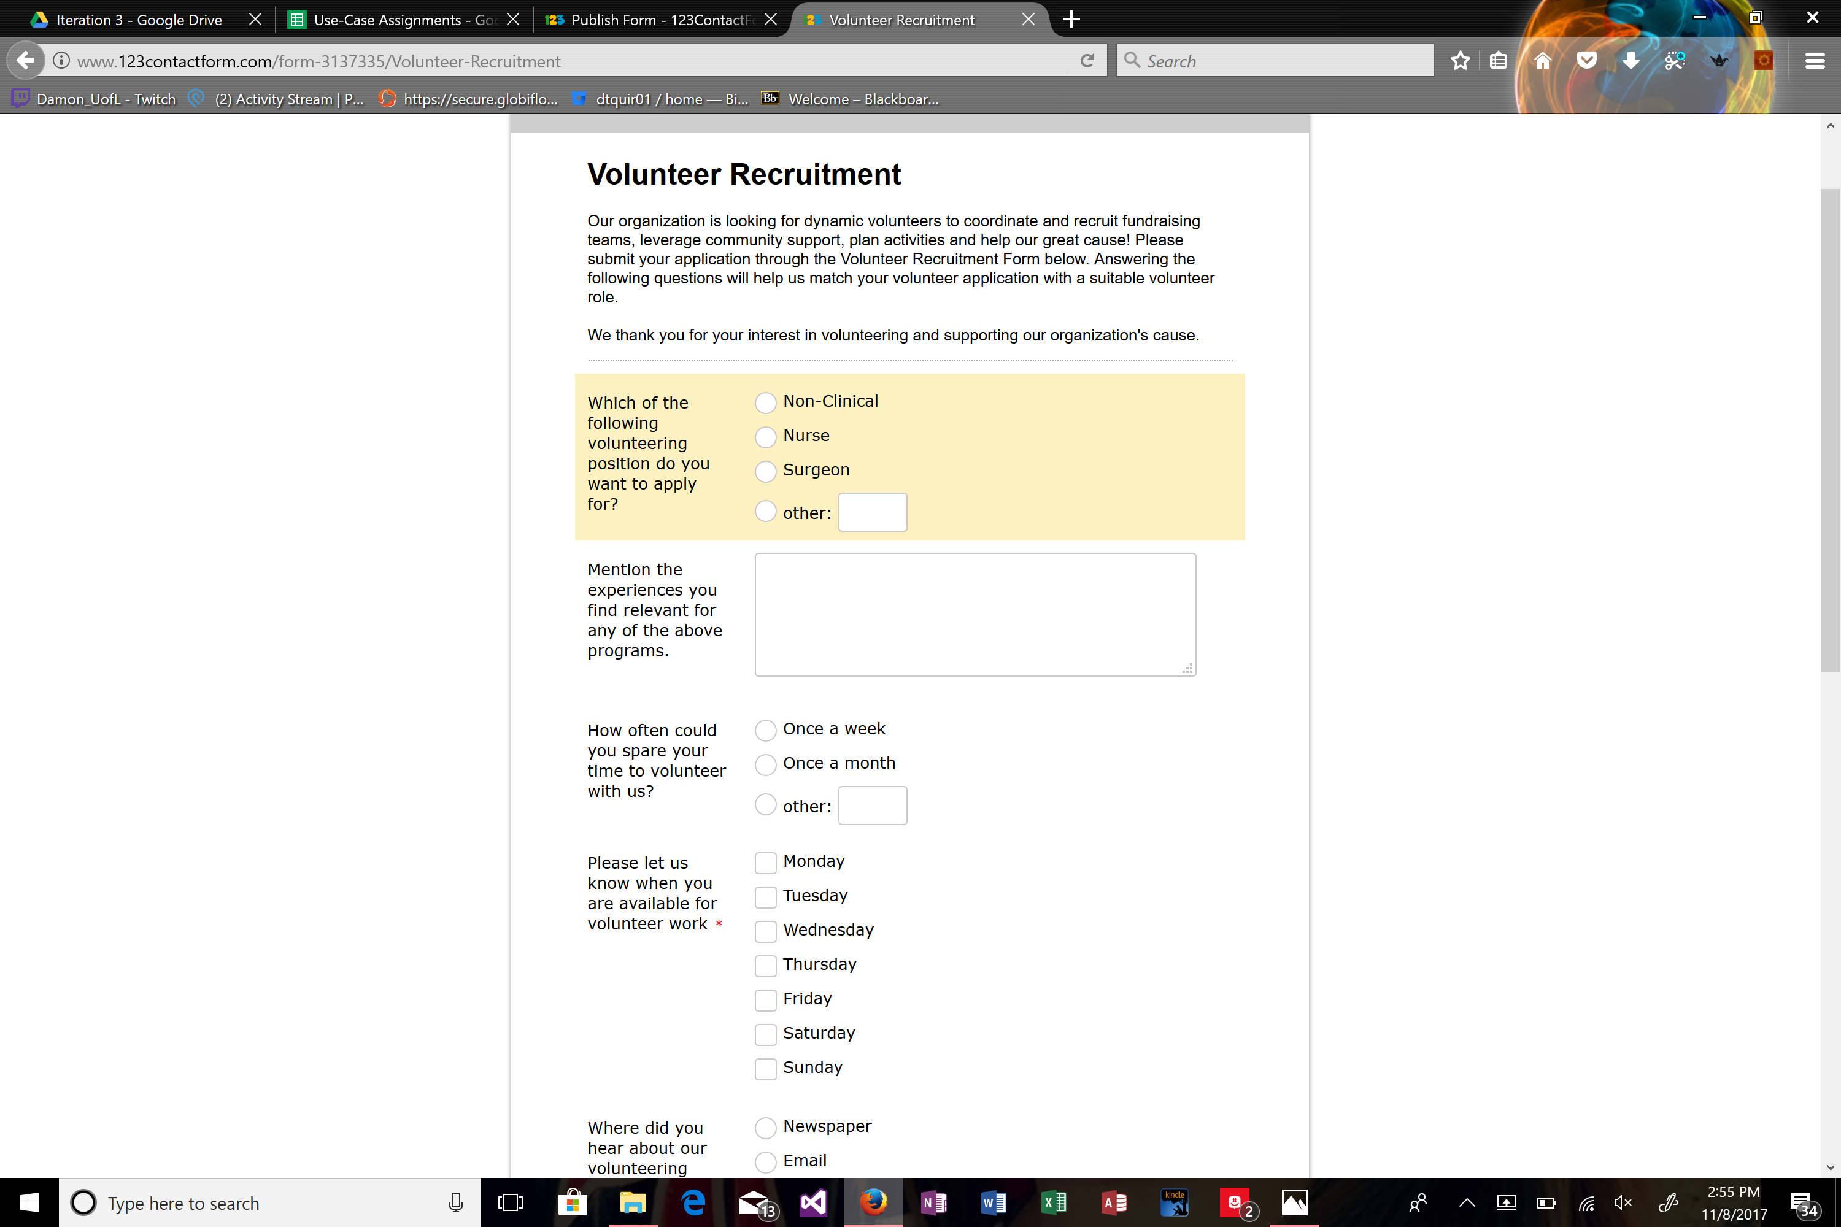

Surgery On Sunday

Version 1.0

Revision History

|  |  |  |  |
| --- | --- | --- | --- |
| **Date** | **Version** | **Description** | **Author** |
| 10/23/2017 | 1.0 | Update Non-Clinical Volunteer Information | Damon Quire |
|  |  |  |  |
|  |  |  |  |
|  |  |  |  |

Table of Contents

1. Update Non-Clinical Volunteer Information 4

1.1 Brief Description 4

2. Flow of Events 4

2.1 Basic Flow 4

2.2 Alternative Flows 4

3. Special Requirements 4

3.1 User Must be Logged In, Information Must be Available 4

4. Pre-conditions 4

4.1 User Must be Logged In 4

5. Post-conditions 4

5.1 Information is Updated 4

6. Extension Points 4

Use Case Specification: Update Non-Clinical Volunteer Information

# Update Non-Clinical Volunteer Information Brief Description

The objective of this use case is to show how an IT coordinator would go about updating a volunteer’s information. This is necessary so that SOS can appropriately change the info of a volunteer in case they change phone numbers, move, or many other occurrences that would cause this to be needed. This way, instead of manually searching through all of the files available on volunteers, they instead can access quickly the exact volunteer form, click edit, and change the information directly.

# Flow of Events

## Basic Flow

* A user wants to update volunteer information
* IT Coordinator logs in with their authorization
* IT Coordinator navigates to volunteers table
* IT Coordinator finds appropriate volunteer
* IT Coordinator clicks edit
* IT Coordinator views First Name field
* IT Coordinator views Last Name field
* IT Coordinator views City field
* IT Coordinator views State field
* IT Coordinator views Zip field
* IT Coordinator views Address field
* IT Coordinator views Licenses field
* IT Coordinator views Phone number field
* IT Coordinator views Email address field
* IT Coordinator views Hospital affiliation field
* IT Coordinator views Primary language field
* IT Coordinator views Secondary language if exists field
* IT Coordinator selects the appropriate field(s) that needs changed
* IT Coordinator types in new attribute
* IT Coordinator clicks save
* IT Coordinator logs out

## Alternative Flows

There are no alternative flows

# Special Requirements

## -User must be logged into their account and have the proper authorization to view and access the data

-Data must already exist in database to be accessed

# Pre-conditions

## User must be logged into the system with appropriate credentials.

# Post-conditions

## Record is updated.

# Extension Points

There are no extension points.



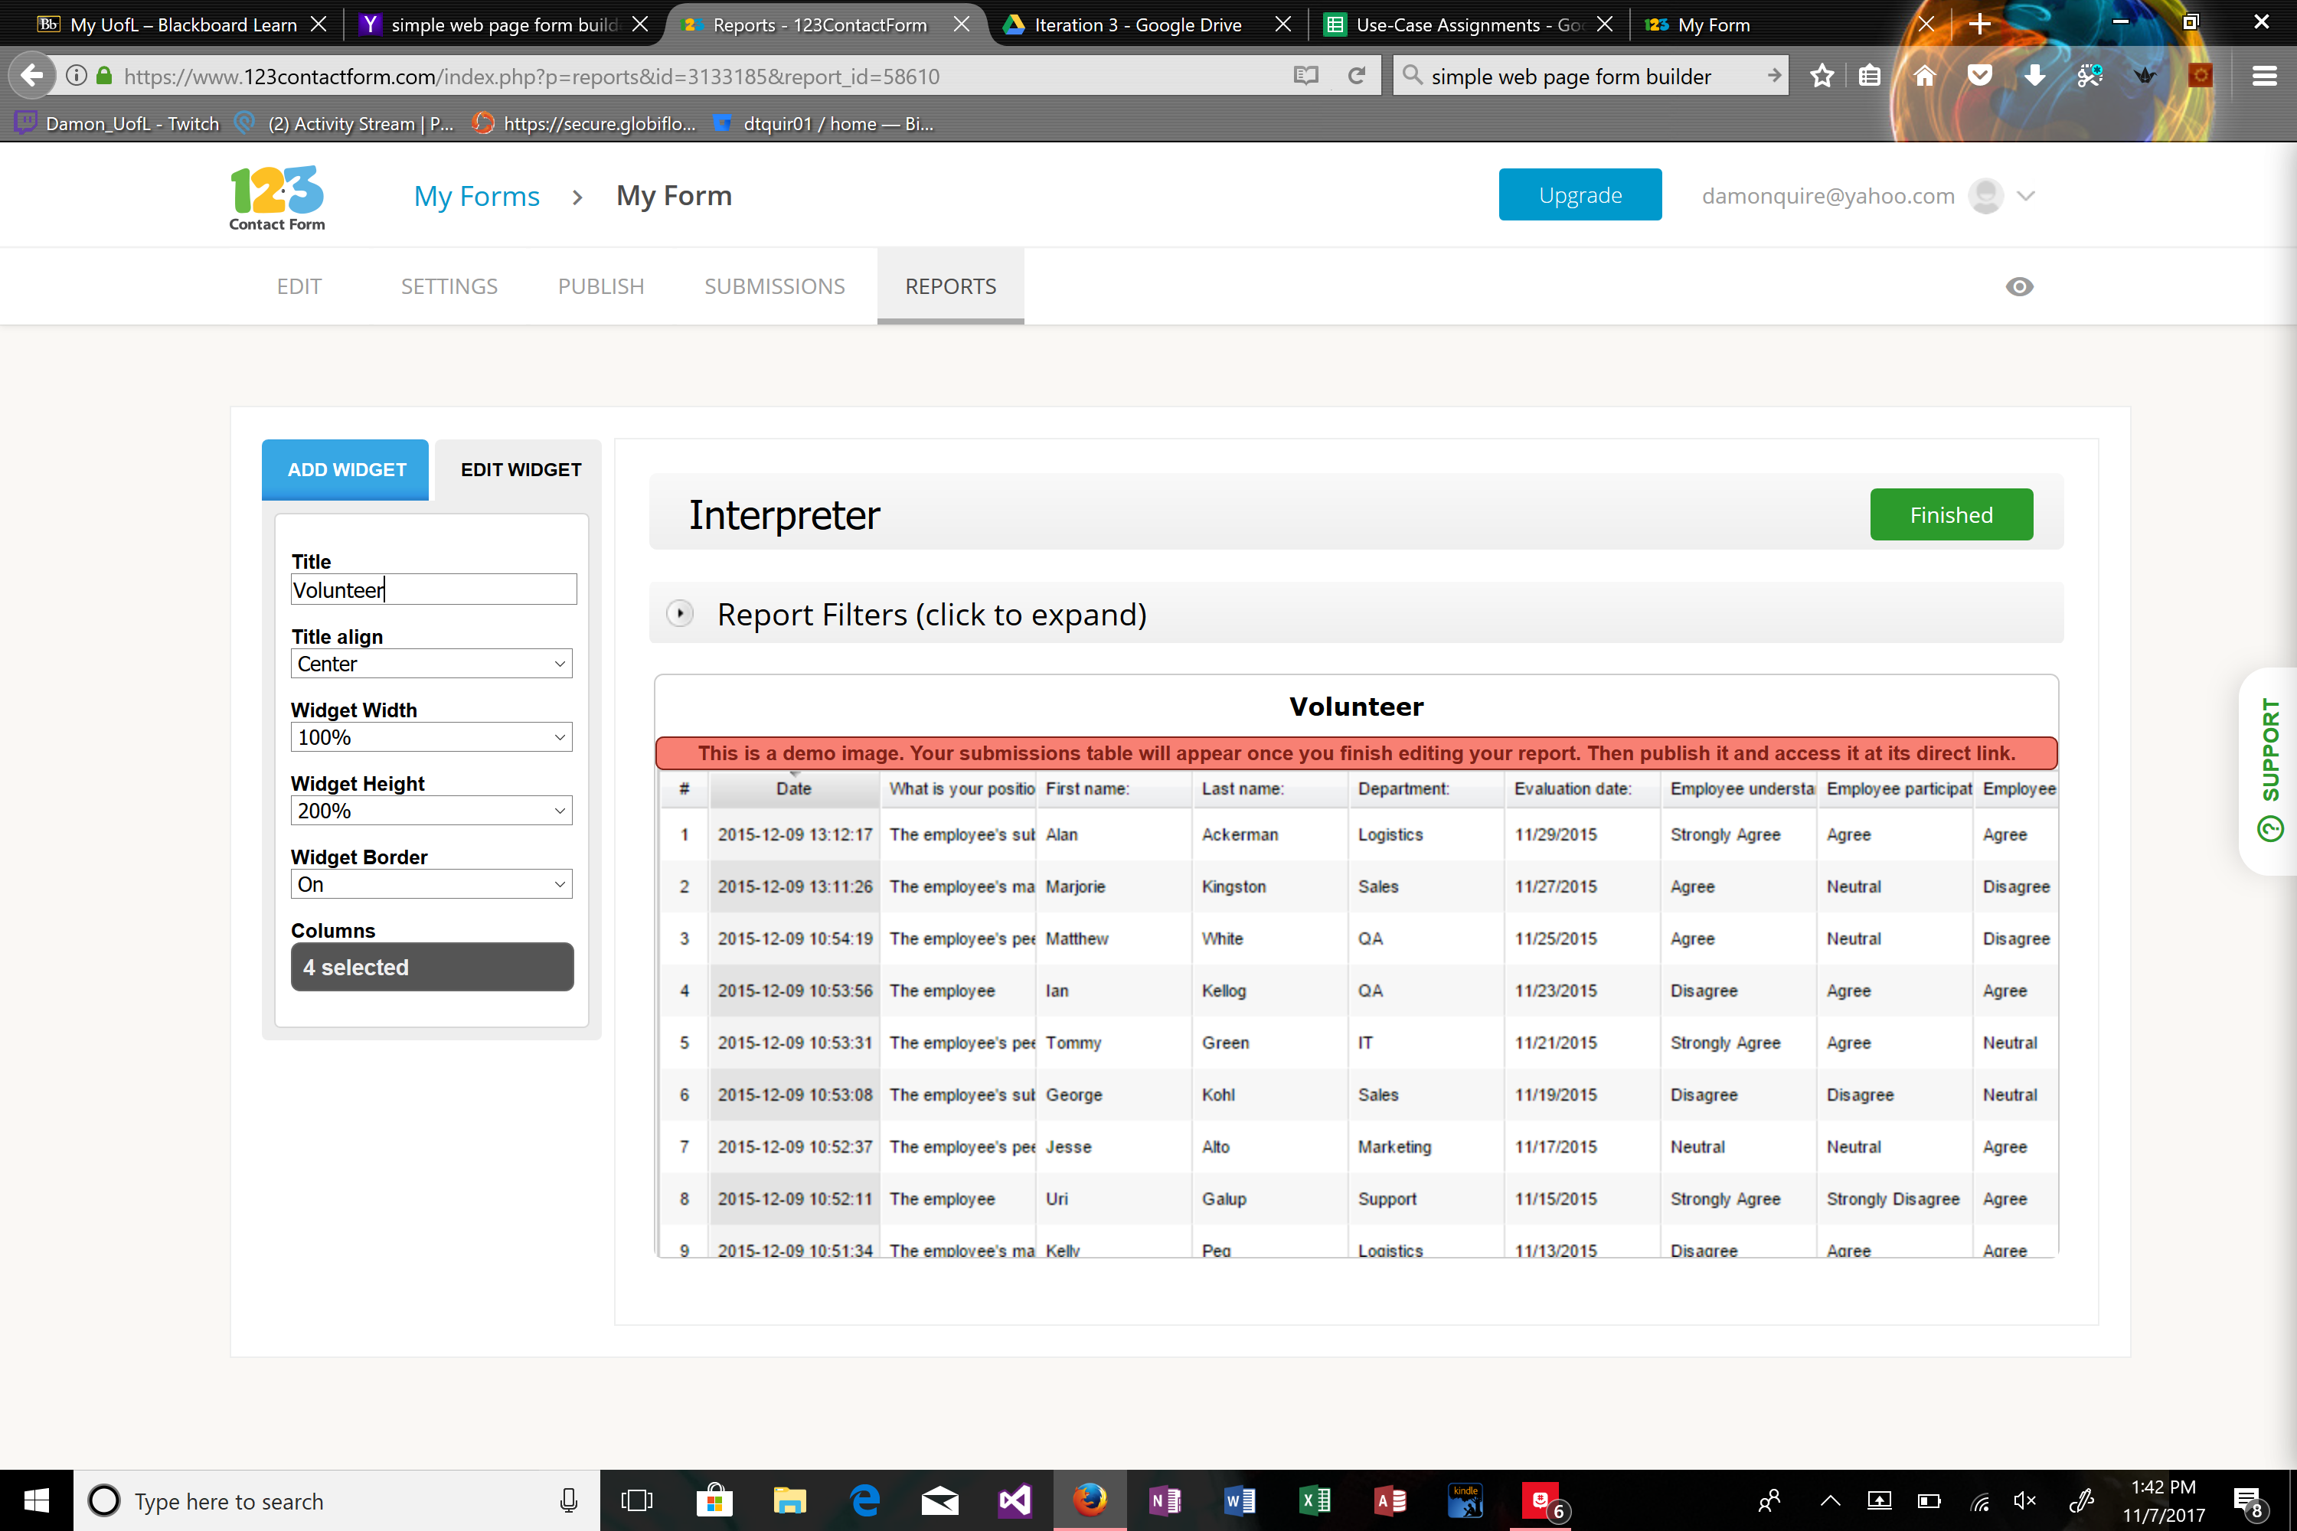

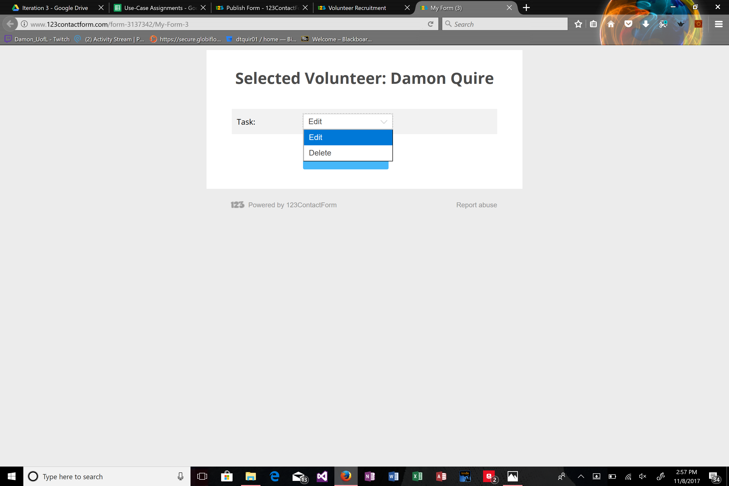

Surgery On Sunday

Version 1.0

Revision History

|  |  |  |  |
| --- | --- | --- | --- |
| **Date** | **Version** | **Description** | **Author** |
| 10/23/2017 | 1.0 | Delete Non-Clinical Volunteer Information | Damon Quire |
|  |  |  |  |
|  |  |  |  |
|  |  |  |  |

Table of Contents

1. Delete Non-Clinical Volunteer Information 4

1.1 Brief Description 4

2. Flow of Events 4

2.1 Basic Flow 4

2.2 Alternative Flows 4

3. Special Requirements 4

3.1 User Must be Logged In, Information Must be Available 4

4. Pre-conditions 4

4.1 User Must be Logged In 4

5. Post-conditions 4

5.1 Information is Deleted 4

6. Extension Points 4

Use Case Specification: Delete Non-Clinical Volunteer Information

# Delete Non-Clinical Volunteer Information Brief Description

The objective of this use case is to show how an IT coordinator would go about deleting a volunteer’s information. This is necessary so that SOS can appropriately remove the info of a volunteer in case they move far away, don’t have time to volunteer anymore, or other reasons that would warrant this system capability. This way, instead of manually searching through all of the files available on volunteers, they instead can access quickly the exact volunteer form and delete the record.

# Flow of Events

## Basic Flow

* A user wants to delete volunteer information
* IT Coordinator logs in with their authorization
* IT Coordinator navigates to volunteers table
* IT Coordinator finds appropriate volunteer record
* IT Coordinator clicks delete
* IT Coordinator clicks save
* IT Coordinator logs out

## Alternative Flows

There are no alternative flows

# Special Requirements

## -User must be logged into their account and have the proper authorization to view and access the data

-Data must already exist in database to be accessed

# Pre-conditions

## User must be logged into the system with appropriate credentials.

# Post-conditions

## Record is deleted.

# Extension Points

There are no extension points.



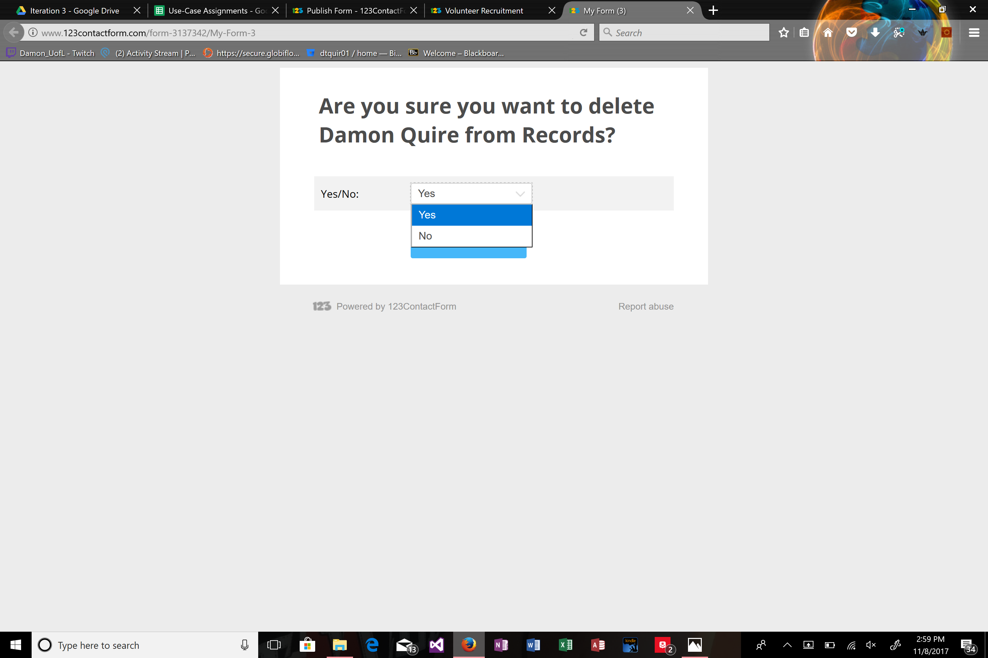

Surgery On Sunday

Use Case Specification: Generate Non-Clinical Volunteer Report

Version 1.0

Revision History

|  |  |  |  |
| --- | --- | --- | --- |
| **Date** | **Version** | **Description** | **Author** |
| 10/23/2017 | 1.0 | Generate Non-Clinical Volunteer Report | Damon Quire |
|  |  |  |  |
|  |  |  |  |
|  |  |  |  |

Table of Contents

1. Generate Non-Clinical Volunteer Report 4

1.1 Brief Description 4

2. Flow of Events 4

2.1 Basic Flow 4

2.2 Alternative Flows 4

3. Special Requirements 4

3.1 User Must be Logged In, Information Must be Available 4

4. Pre-conditions 4

4.1 User Must be Logged In 4

5. Post-conditions 4

5.1 Information is Displayed 4

6. Extension Points 4

Use Case Specification: Generate Non-Clinical Volunteer Report

# Generate Non-Clinical Volunteer Report

## Brief Description

The objective of this use case is to show how a program coordinator would go about requesting a report about the available non-clinical volunteers. This is necessary so that SOS can appropriately assign the correct volunteers based on the patient’s surgery and volunteer availability. This way, instead of manually searching through all of the files available on volunteers, they instead can obtain a report showing all available staff or volunteers that are qualified and available for a certain event.

# Flow of Events

## Basic Flow

* A user wants to access non-clinical volunteer information for a particular surgery’s needs
* Program Coordinator logs in with their authorization
* Program Coordinator navigates to reports tab
* Program Coordinator navigates to non-clinical volunteers within reports
* Program Coordinator saves or prints reports with necessary data
* Program Coordinator logs out of system

## Alternative Flows

There are no alternative flows

# Special Requirements

## -User must be logged into their account and have the proper authorization to view and access the data.

-Data must already exist in database to be accessed.

# Pre-conditions

## User must be logged into the system with appropriate credentials.

# Post-conditions

## Information on volunteers is displayed and may be saved or printed.

# Extension Points

There are no extension points.







Surgery On Sunday

Use Case Specification: Send Email to Non-Clinical Volunteers

Version 1.0

Revision History

|  |  |  |  |
| --- | --- | --- | --- |
| **Date** | **Version** | **Description** | **Author** |
| 10/23/2017 | 1.0 | Send Email to Non-Clinical Volunteers | Damon Quire |
|  |  |  |  |
|  |  |  |  |
|  |  |  |  |

Table of Contents

1. Send Email to Non-Clinical Volunteers 4

1.1 Brief Description 4

2. Flow of Events 4

2.1 Basic Flow 4

2.2 Alternative Flows 4

3. Special Requirements 4

3.1 User Must be Logged In, Information Must be Available, Volunteer Supplied Data 4

4. Pre-conditions 4

4.1 User Must be Logged In 4

5. Post-conditions 4

5.1 Email is Sent 4

6. Extension Points 4

Use Case Specification: Send Email to Non-Clinical Volunteers

# Send Email to Non-Clinical Volunteers

## Brief Description

The objective of this use case is to show how a program coordinator would go about emailing available non- clinical volunteers. This is necessary so that SOS can appropriately assign the correct volunteers based on the patient’s surgery and the volunteer’s availability. This way, instead of manually searching through all of the files available on volunteers, they instead access all of the email addresses of qualified volunteers and ask them about their availability, or should they have already signed up, remind them of the upcoming event and supply them with further details.

# Flow of Events

## Basic Flow

* A user wants to access appropriate volunteer email addresses
* Program Coordinator logs in with their authorization
* Program Coordinator navigates to reports tab
* Program Coordinator navigates to non-clinical volunteers within reports
* Program Coordinator finds appropriate volunteers
* Program Coordinator accesses their email addresses
* Program Coordinator imports them to plugin
* Program Coordinator sends email to all possible/already signed up volunteers
* Program Coordinator logs out of system

## Alternative Flows

There are no alternative flows

# Special Requirements

## -User must be logged into their account and have the proper authorization to view and access the data

-Data must already exist in database to be accessed

-Volunteer must have supplied email address prior to accessing

# Pre-conditions

## User must be logged into the system with appropriate credentials.

# Post-conditions

## Email is sent to appropriate email addresses

# Extension Points

There are no extension points.





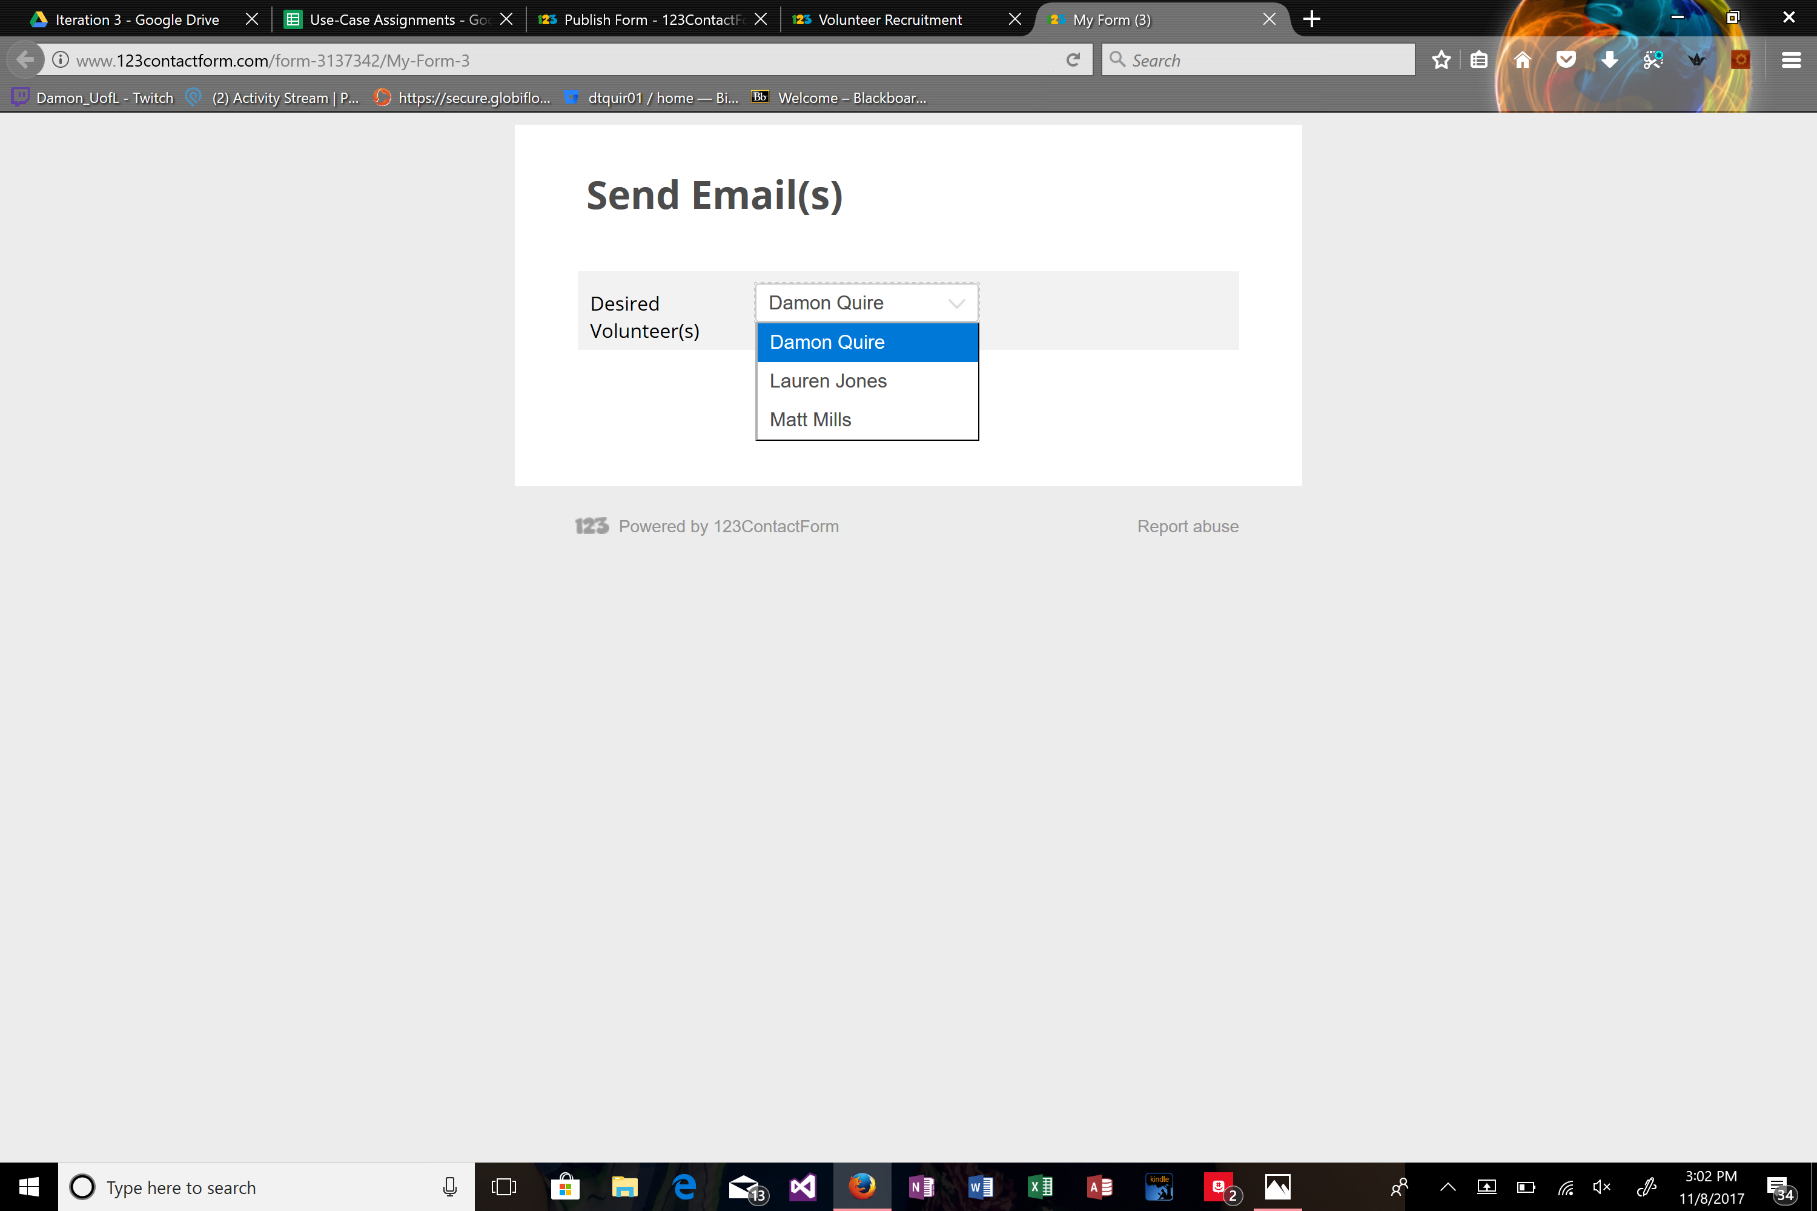

Surgery On Sunday

Use Case Specification: Schedule Event With Non-Clinical Volunteers

Version 1.0

Revision History

|  |  |  |  |
| --- | --- | --- | --- |
| **Date** | **Version** | **Description** | **Author** |
| 10/23/2017 | 1.0 | Schedule Event With Non-Clinical Volunteers | Damon Quire |
|  |  |  |  |
|  |  |  |  |
|  |  |  |  |

Table of Contents

1. Schedule Event With Non-Clinical Volunteers 4

1.1 Brief Description 4

2. Flow of Events 4

2.1 Basic Flow 4

2.2 Alternative Flows 4

3. Special Requirements 4

3.1 User Must be Logged In, Information Must be Available 4

4. Pre-conditions 4

4.1 User Must be Logged In 4

5. Post-conditions 4

5.1 Event is Scheduled 4

6. Extension Points 4

Use Case Specification: Schedule Event With Non-Clinical Volunteers

# Schedule Event With Non-Clinical Volunteers

## Brief Description

The objective of this use case is to show how a program coordinator would go about scheduling an event with the available volunteers. This is necessary so that SOS can appropriately assign the correct non-clinical based on the patient’s surgery availability of the volunteer. This way, instead of manually searching through all of the files available on volunteers, they instead access all of the qualified volunteers and can schedule the event with those available and qualified.

# Flow of Events

## Basic Flow

* A user wants to schedule an event
* Program Coordinator logs in with their authorization
* Program Coordinator navigates to schedule event tab
* Program Coordinator fills out date of event field
* Program Coordinator fills out location of event field
* Program Coordinator fills out patient field
* Program Coordinator fills out selected nurses field
* Program Coordinator fills out surgeon field
* Program Coordinator fills out selected interpreter field
* Program Coordinator navigates to non-clinical volunteer section
* Program Coordinator fills out selected non-clinical volunteers field
* Program Coordinator clicks submit/schedule
* Program Coordinator logs out of system

## Alternative Flows

There are no alternative flows

# Special Requirements

## -User must be logged into their account and have the proper authorization to view and access the data

-Data must already exist in database to be accessed

# Pre-conditions

## User must be logged into the system with appropriate credentials.

# Post-conditions

## Event is Scheduled

# Extension Points

There are no extension points.



